Sort a Stack
Mark as Completed
0
Problem Statement: You are given a stack of integers. Your task is to sort the stack in descending order using recursion, such that the top of the stack contains the greatest element. You are not allowed to use any loop-based sorting methods (e.g., quicksort, mergesort). You may only use recursive operations and the standard stack operations (push, pop, peek/top, and isEmpty).
Examples
Example 1:
Input: stack = [4, 1, 3, 2]
Output: [4, 3, 2, 1]
Explanation: After sorting, the largest element (4) is at the top, and the smallest (1) is at the bottom.

Example 2:
Input: stack = [1]
Output: [1]
Explanation: A single-element stack is already sorted.
Disclaimer: Here is the practice link to help you assess your knowledge better. It's highly recommend trying to solve it before looking at the solution.
Approach

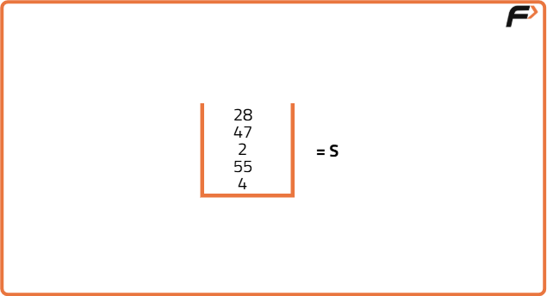
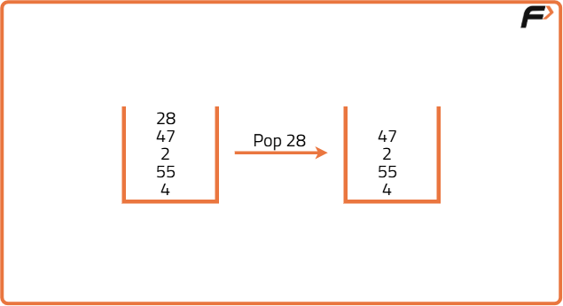
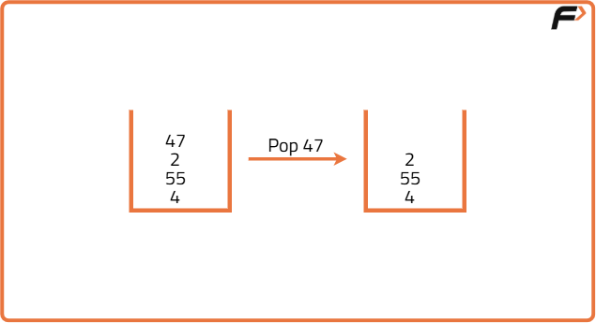
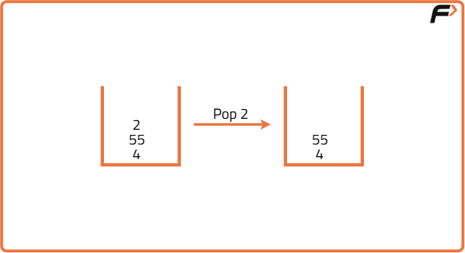
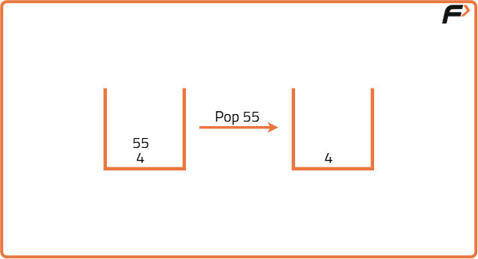
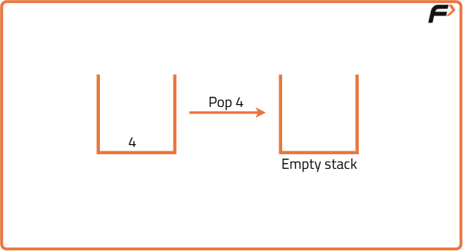
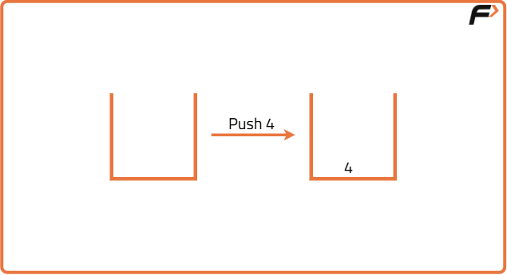
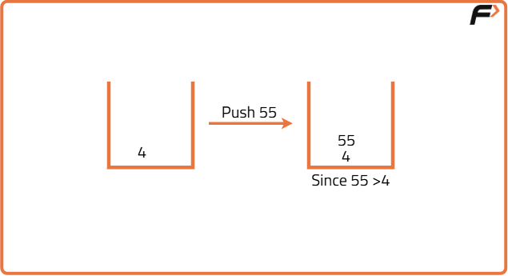
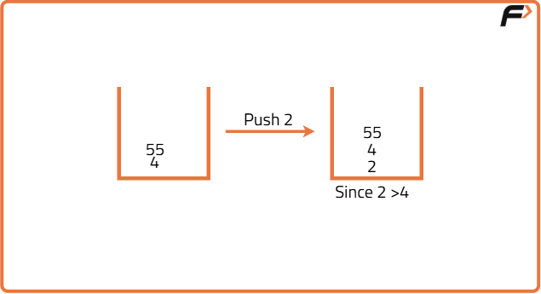
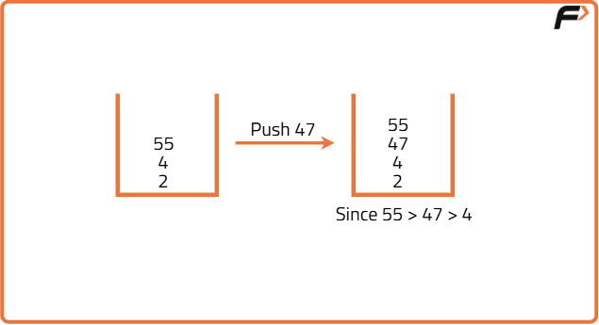
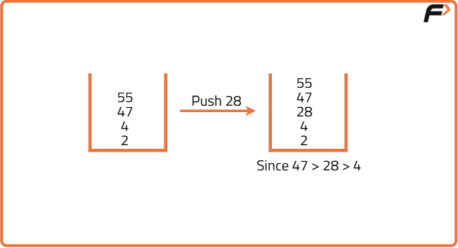
import java.util.Stack;

class Solution {
// Function to insert element in sorted order
public void insert(Stack<Integer> stack, int temp) {
if (stack.isEmpty() || stack.peek() <= temp) {
stack.push(temp);
return;
}

// Pop the top element and recursively insert
int val = stack.pop();
insert(stack, temp);

// Push the popped element back
stack.push(val);
}

// Function to sort the stack
public void sortStack(Stack<Integer> stack) {
if (!stack.isEmpty()) {
int temp = stack.pop();
sortStack(stack);
insert(stack, temp);
}
}
}
Time Complexity: O(n²), where n is the number of elements in the stack.
Space Complexity: O(n), due to the recursion stack.

